**Template4u LTD**



**Company description**

Our company will sell website templates.

|  |  |
| --- | --- |
| Order | Jakub Zarzycki |
| Staff | Alex Longhurst |
| Customers | Patryk Wegrzynski |
| Products list | Dawid Malecki |
| Template reviews | Dominik Michalski |

**System Overview**

This company will sell website templates to the general public. They can order an already created design which they can use to form their own webpage. They can browse and filter this available collection of webpage designs. There will be an option for customers to add their web page templates to a shopping cart and create an order. After having made an order, the customer can leave a review for the template. They will then be required to create a customer account where they specify payment and personal details. They will also be able to review and validate the orders in their shopping cart.

Once an order is created by the customer it will be added to a list of orders for processing at the back end. The back end will allow for a range of admin functions such as managing customer data, staff data, stock and running various reports on data stored in the system e.g. orders placed.

**ERD**

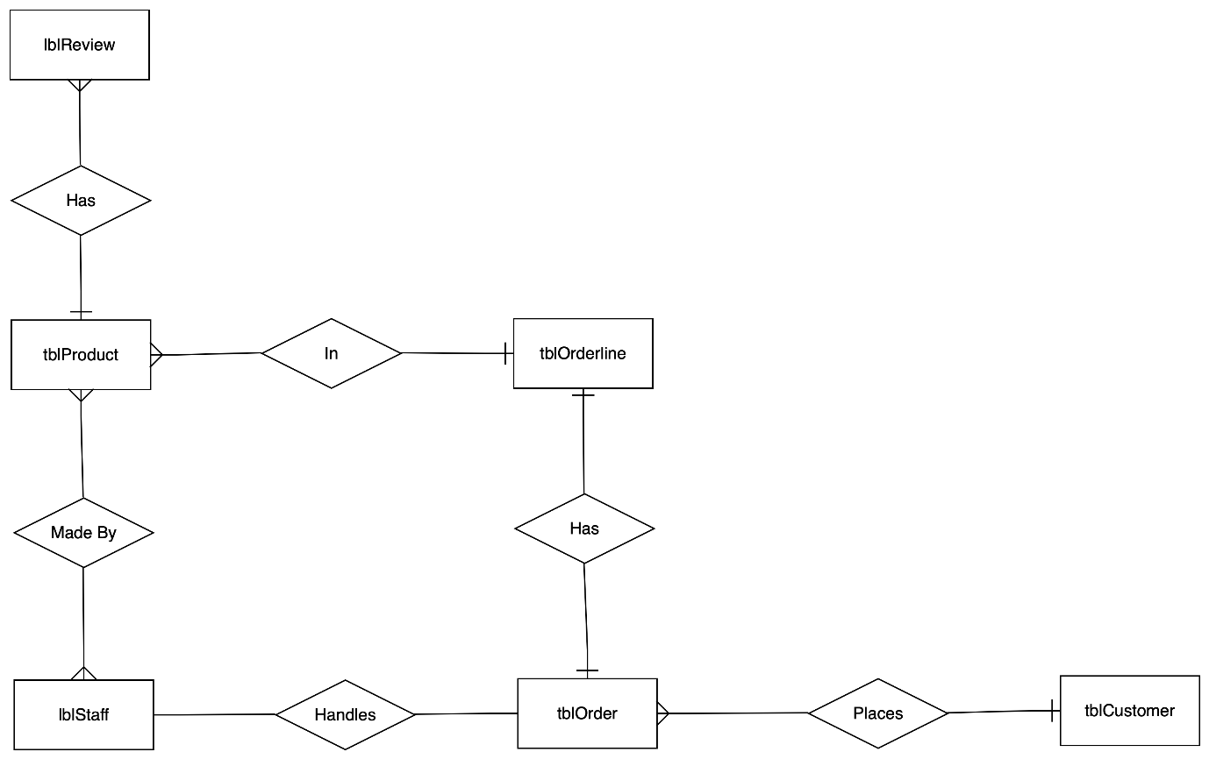

**Creates**

**Class Diagram**

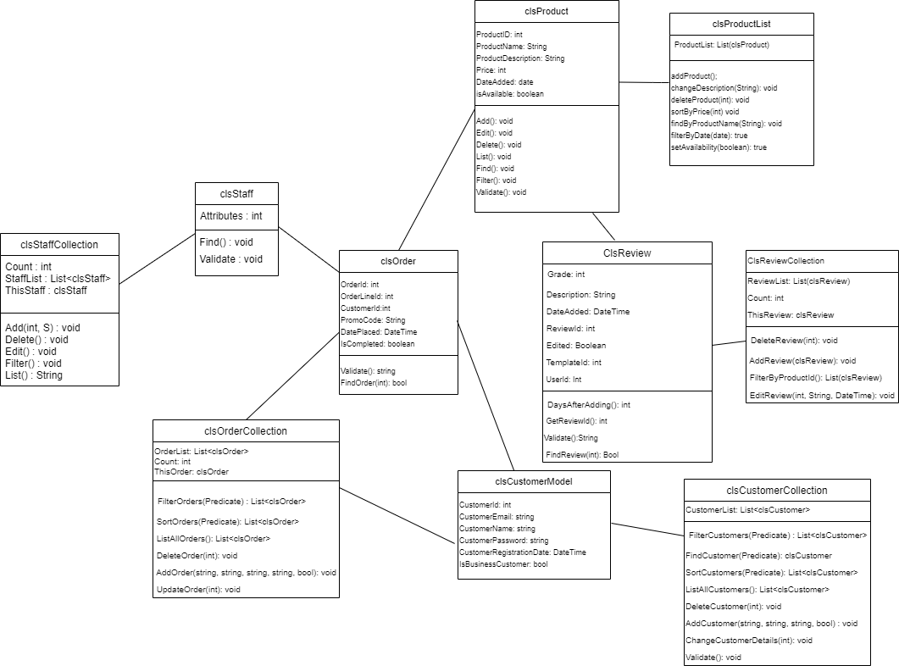

**Template4u LTD**



**Allocated Component:** Template reviews

**Developer:** Dominik Michalski

**Overview:**

After template choice, purchase and implementation customers have a chance to rate chosen product. Review will consist of star-based rate (1-5 stars) and comment which is optional. Customers can add a review and edit it. However, when they once added a review, they cannot delete it. To prevent bad reviews caused by circumstances that happened after long time period, editing should be restricted - it will be possible only two weeks after it has been added. It will be marked as edited as well. App is to display list of templates with their user satisfaction rate (1.0-5.0) which is a mean of all reviews. When template is clicked it shows another list consists of usernames together with their reviews. On the back-end staff can delete any review that is not consistent with company policies. Staff cannot edit or add any reviews.

**Individual Table Designs**

tblReview

|  |  |
| --- | --- |
| ReviewID | Int Primary Key |
| Grade | Int not NULL |
| ReviewComment | Text |
| DateAdded | Date |
| UserID | varchar(20) Foreign Key not NULL |
| Edited | Boolean |
| ProductId | int Foreign key not NULL |

Use Cases:

Component – Review

Author – Dominik

|  |  |
| --- | --- |
| Use Case Name | Insert Review |
| Use Case Description | User can add a review, it must contain grade and product id |
| Use Case Author | Dominik |
| Actor(s) | Users |
| Locations | Mainly back end |
| Primary pathway | User adds review using web form, it appears in the database to be validated by administrator |
| Alternate pathways | User adds description as well |
| Exception pathways | User doesn’t specify which product has been reviewed, or product hasn’t been bought by this customer so it cannot be reviewed, database connection failure is possible as well |

|  |  |
| --- | --- |
| Use Case Name | Edit Review |
| Use Case Description | User can edit added review if it’s not too late (2 weeks after adding) |
| Use Case Author | Dominik |
| Actor(s) | Users |
| Locations | Mainly back end |
| Primary pathway | User edits a review using web form and specifying new grade |
| Alternate pathways | User edits also a description |
| Exception pathways | It has been more than 2 weeks since review was added,  database connection failure is possible as well |

|  |  |
| --- | --- |
| Use Case Name | View reviews |
| Use Case Description | User can view reviews of chosen template |
| Use Case Author | Dominik |
| Actor(s) | Users |
| Locations | Front end (grid with reviews) with back end (Database) |
| Primary pathway | User specifies of which template review is to be viewed, then grid with all reviews appears |
| Alternate pathways | -------------------------------------- |
| Exception pathways | There are no reviews for given template, database failure |

|  |  |
| --- | --- |
| Use Case Name | Sort reviews |
| Use Case Description | User can sort reviews |
| Use Case Author | Dominik |
| Actor(s) | Users |
| Locations | Back End (selecting from database) and front end (view in app) |
| Primary pathway | User chooses in which way they want to sort selected reviews (date, grade) |
| Alternate pathways | -------------------------------------- |
| Exception pathways | Database failure |

|  |  |
| --- | --- |
| Use Case Name | Validate review |
| Use Case Description | Administrators must check the review before adding if it is consistent with law and company policy |
| Use Case Author | Dominik |
| Actor(s) | Administrator |
| Locations | Backend |
| Primary pathway | Review is accepted as it is consistent with the policy |
| Alternate pathways | Review is rejected as it breaches company policy or, in general, law |
| Exception pathways | Database failure |

|  |  |
| --- | --- |
| Use Case Name | Find Review |
| Use Case Description | User can find review using its Id |
| Use Case Author | Dominik |
| Actor(s) | Users |
| Locations | Backend |
| Primary pathway | Requested review appears on the screen |
| Alternate pathways | -------------------------------------- |
| Exception pathways | Database failure, ID does not exist |

**Individual Use case diagram**

<<include>>

Validate Review

Add Review

<<include>>

<<include>>

Find Review



<<include>>

Edit Review

Delete Review Review

**User**

**Administrator**

Filter Reviews

<<extend>>

List Reviews

**Template4u LTD**



**Allocated Component:** Customer

**Developer:** Patryk Wegrzynski

**Overview:**

A customer visits the website to buy the templates for the site. The system differentiates if the customer is a business or private customer. To become a customer, the user first has to sign up for the web service. During the signup process, the customer has to provide the website with some data within the form, such as user credentials, address, and check if the user is signing up for business or private purposes. Once the user signs up for the website, the templates are available to add to the basket and be checked out. User can change their data or close the account if needed.

On the back end, the customer system is responsible for associating the basket with a specific user to finalise the order correctly.

Customer must be added to the database to continue to the website. Still, first, the customer credentials have to be validated through the system. Once the customer is in the database, the account can be edited or deleted if necessary. During the registration process user sets the account type as a business or just standard account. Based on that info users can be filtered and special promotions can be added to the business or standard clients.

**Database name:** Template4u

**Table name:** Customer

**Database design:**

|  |  |
| --- | --- |
| **Columns** | **Properties** |
| CustomerId | Int Primary Key |
| CustomerEmail | VARCHAR(50) |
| CustomerPassword | VARCHAR(50) |
| CustomerName | VARCHAR(50) |
| CustomerRegistrationDate | DateTime |
| IsCustomerBussinessClient | Boolean |

**Use cases:**

Component – Customer

Author – Patryk

|  |  |
| --- | --- |
| Use Case Name (Short two- or three-word name) | Add Customer |
| Use Case Description (Short description) | Adding customer to the system database |
| Use Case Author(s) (Who wrote this) | Patryk |
| Actor(s) (Who does this) | Customer / Administrator |
| Locations (Where does this happen) | Class lib functionality |
| Primary pathway (What is the normal “happy path” for this use case?) | Add user to database |
| Alternate pathways (What other paths are there that are not the “happy path”?) | The user cannot be added to the system – an error message occurs. |
| Exception pathways (What could possibly go wrong?) | Database connection fails.  User already exists in the database. |

|  |  |
| --- | --- |
| Use Case Name (Short two- or three-word name) | Update Customer |
| Use Case Description (Short description) | Updating user related data in the database |
| Use Case Author(s) (Who wrote this) | Patryk |
| Actor(s) (Who does this) | Customer / Administrator |
| Locations (Where does this happen) | Class lib functionality |
| Primary pathway (What is the normal “happy path” for this use case?) | User data successfully updated in the database. |
| Alternate pathways (What other paths are there that are not the “happy path”?) | User does not exist in the database so it cannot be updated.  User tries to update account with incorrect data – error occurs. |
| Exception pathways (What could possibly go wrong?) | Database connection fails.  User does not exist in the database. |

|  |  |
| --- | --- |
| Use Case Name (Short two- or three-word name) | Delete Customer |
| Use Case Description (Short description) | Deletes user from the system database. |
| Use Case Author(s) (Who wrote this) | Patryk |
| Actor(s) (Who does this) | Customer / Administrator |
| Locations (Where does this happen) | Class lib functionality |
| Primary pathway (What is the normal “happy path” for this use case?) | User successfully deleted from the database. |
| Alternate pathways (What other paths are there that are not the “happy path”?) | User cannot be deleted as he does not exist in the database. |
| Exception pathways (What could possibly go wrong?) | Database connection fails.  User does not exist in the database. |

|  |  |
| --- | --- |
| Use Case Name (Short two- or three-word name) | Validate |
| Use Case Description (Short description) | Check if data provided is correct and can be added to the database. |
| Use Case Author(s) (Who wrote this) | Patryk |
| Actor(s) (Who does this) | Administrator |
| Locations (Where does this happen) | Class lib |
| Primary pathway (What is the normal “happy path” for this use case?) | Data is validated and correct. Data added to the database system. |
| Alternate pathways (What other paths are there that are not the “happy path”?) | Data is invalid and cannot be added to the database. |
| Exception pathways (What could possibly go wrong?) | Database connection fails.  Data is not provided in correct format; invalid data – error occurs |

|  |  |
| --- | --- |
| Use Case Name (Short two or three word name) | Find |
| Use Case Description (Short description) | Search for the user in the database. |
| Use Case Author(s) (Who wrote this) | Patryk |
| Actor(s) (Who does this) | Customer / Administrator |
| Locations (Where does this happen) | Front End / Class lib |
| Primary pathway (What is the normal “happy path” for this use case?) | User has been found. Show user data to the customer |
| Alternate pathways (What other paths are there that are not the “happy path”?) | User does not exist in the database. |
| Exception pathways (What could possibly go wrong?) | Database connection fails.  User does not exist in the database – error occurs |

|  |  |
| --- | --- |
| Use Case Name (Short two- or three-word name) | Filter |
| Use Case Description (Short description) | Filter all user |
| Use Case Author(s) (Who wrote this) | Patryk |
| Actor(s) (Who does this) | Administrator |
| Locations (Where does this happen) | Front End / Class lib |
| Primary pathway (What is the normal “happy path” for this use case?) | List all filtered customer within the database. |
| Alternate pathways (What other paths are there that are not the “happy path”?) | There is no user within specified filter.  System show no users |
| Exception pathways (What could possibly go wrong?) | Database connection fails.  Users within specified filter does not exist – error occurs |

|  |  |
| --- | --- |
| Use Case Name (Short two- or three-word name) | List |
| Use Case Description (Short description) | Lists all users available in the system database. |
| Use Case Author(s) (Who wrote this) | Patryk |
| Actor(s) (Who does this) | Administrator |
| Locations (Where does this happen) | Front End / Class lib |
| Primary pathway (What is the normal “happy path” for this use case?) | System lists all customers. |
| Alternate pathways (What other paths are there that are not the “happy path”?) | There is no data available in the system. |
| Exception pathways (What could possibly go wrong?) | Database connection fails.  No users exist in the system – error occurs |

**Individual Use Case Diagram:**

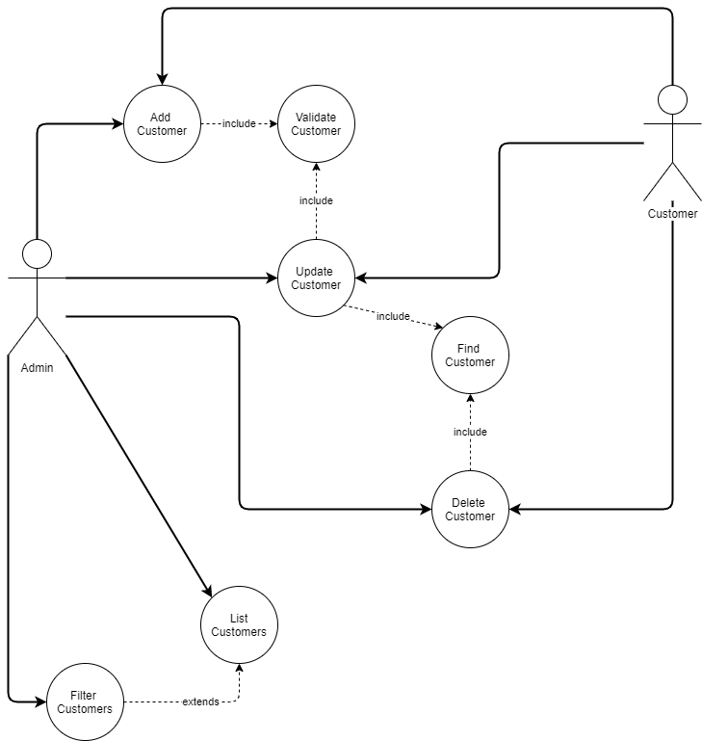

**Template4u LTD**



**Template4u**

**Allocated Component:** Order

**Developer:** Jakub Zarzycki

**Overview:**

This component is created for the Administrator, so it is easier for him/her to handle orders. Administrator has the option to list all the orders that are currently in the database. He/She, can find a particular order using OrderId and can also update it or remove it. Moreover, Administrator is able to add new orders. He/She can filter and sort orders by a given predicate. This component is also available for user. User can add and edit his orders.

**Oder Table design:**

OrderId Int Primary Key

CustomerId Int Foreign key

OrderLineId Int Foreign key

PromoCode Text

DatePlaced Date

IsCompleted Boolean

**Use cases:**

|  |  |
| --- | --- |
| Use Case Name (Short two or three word name) | Add order |
| Use Case Description (Short description) | Administrator/user adds an order to the list. |
| Use Case Author(s) (Who wrote this) | Jakub |
| Actor(s) (Who does this) | Administrator/user |
| Locations (Where does this happen) | Front and back end functionality |
| Primary pathway (What is the normal “happy path” for this use case?) | Add order  Administrator/user adds an order to the database.  An order is added to the order collection. |
| Alternate pathways (What other paths are there that are not the “happy path”?) | Some required fields are missing- an error is displayed saying so.  Invalid data is entered and an error appears. |
| Exception pathways (What could possibly go wrong?) | Database connection fails  Error displayed advising of connection problem |

|  |  |
| --- | --- |
| Use Case Name (Short two or three word name) | List orders. |
| Use Case Description (Short description) | Administrator views a list of orders in the database. |
| Use Case Author(s) (Who wrote this) | Jakub |
| Actor(s) (Who does this) | Administrator |
| Locations (Where does this happen) | Front and back end functionality |
| Primary pathway (What is the normal “happy path” for this use case?) | Open list of orders.  Administrator clicks on the list orders button.  A list of orders in the database is displayed to the Administrator. |
| Alternate pathways (What other paths are there that are not the “happy path”?) | Order list is empty – a message is displayed saying so. |
| Exception pathways (What could possibly go wrong?) | Database connection fails  Error displayed advising of connection problem |

|  |  |
| --- | --- |
| Use Case Name (Short two or three word name) | Remove order |
| Use Case Description (Short description) | Admin removes order from the order collection. |
| Use Case Author(s) (Who wrote this) | Jakub |
| Actor(s) (Who does this) | Administrator |
| Locations (Where does this happen) | Front and back end functionality |
| Primary pathway (What is the normal “happy path” for this use case?) | Remove order  Administrator removes order from the order list.  Order is removed from the list of orders in order collection. |
| Alternate pathways (What other paths are there that are not the “happy path”?) | There’s no such order in the database – an error is displayed. |
| Exception pathways (What could possibly go wrong?) | Database connection fails  Error displayed advising of connection problem |

|  |  |
| --- | --- |
| Use Case Name (Short two or three word name) | Edit Order |
| Use Case Description (Short description) | Administrator/user edits an order |
| Use Case Author(s) (Who wrote this) | Jakub |
| Actor(s) (Who does this) | Administrator/user |
| Locations (Where does this happen) | Front and back end functionality |
| Primary pathway (What is the normal “happy path” for this use case?) | Update Order  Administrator/user finds an order by its id and edits it. |
| Alternate pathways (What other paths are there that are not the “happy path”?) | Invalid data is entered and an error appears.  Invalid id, there is no such order, an error appears.  Some required fields are missing- an error is displayed saying so. |
| Exception pathways (What could possibly go wrong?) | Database connection fails  Error displayed advising of connection problem |

|  |  |
| --- | --- |
| Use Case Name (Short two or three word name) | Filter orders |
| Use Case Description (Short description) | Administrator filters the order collection using a predicate. |
| Use Case Author(s) (Who wrote this) | Jakub |
| Actor(s) (Who does this) | Administrator |
| Locations (Where does this happen) | Front and back end functionality |
| Primary pathway (What is the normal “happy path” for this use case?) | Filter orders  Administrator views a list of orders filtered by a given predicate. |
| Alternate pathways (What other paths are there that are not the “happy path”?) | Invalid data is entered as a predicate and an error appears.  Order list is empty, an error appears. |
| Exception pathways (What could possibly go wrong?) | Database connection fails  Error displayed advising of connection problem |

|  |  |
| --- | --- |
| Use Case Name (Short two or three word name) | Sort orders |
| Use Case Description (Short description) | Administrator sorts the order collection using a predicate. |
| Use Case Author(s) (Who wrote this) | Jakub |
| Actor(s) (Who does this) | Administrator |
| Locations (Where does this happen) | Front and back end functionality |
| Primary pathway (What is the normal “happy path” for this use case?) | Sort orders  Administrator views a list of orders sorted by a given predicate. |
| Alternate pathways (What other paths are there that are not the “happy path”?) | Invalid data is entered as a predicate and an error appears.  Order list is empty, an error appears. |
| Exception pathways (What could possibly go wrong?) | Database connection fails  Error displayed advising of connection problem |

|  |  |
| --- | --- |
| Use Case Name (Short two or three word name) | Find order |
| Use Case Description (Short description) | Administrator finds the order by id. |
| Use Case Author(s) (Who wrote this) | Jakub |
| Actor(s) (Who does this) | Administrator |
| Locations (Where does this happen) | Front and back end functionality |
| Primary pathway (What is the normal “happy path” for this use case?) | Find order  Administrator uses order id to find a particular order then its displayed on the screen. |
| Alternate pathways (What other paths are there that are not the “happy path”?) | There’s no such order- an error is displayed. |
| Exception pathways (What could possibly go wrong?) | Database connection fails  Error displayed advising of connection problem |

|  |  |
| --- | --- |
| Use Case Name (Short two or three word name) | Validate |
| Use Case Description (Short description) | Checks if entered data is correct and can be added to the database. |
| Use Case Author(s) (Who wrote this) | Jakub |
| Actor(s) (Who does this) | Administrator |
| Locations (Where does this happen) | Back end functionality |
| Primary pathway (What is the normal “happy path” for this use case?) | Validate  Data is validated and then, added to the database |
| Alternate pathways (What other paths are there that are not the “happy path”?) | Data is invalid and an error appears. |
| Exception pathways (What could possibly go wrong?) | Database connection fails  Error displayed advising of connection problem |

**Use case diagram:**

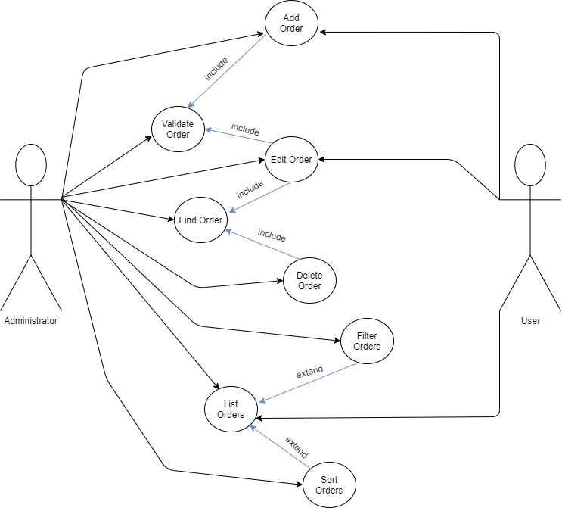

**Template4u LTD**



**Individual Specification for Staff Management – Alex Longhurst**

A staff member is defined as an approved account holder who is permitted to design website templates.

A system administrator may go on the webpage in order to add a staff member. These members are able to add and remove staff members from the site as well as edit staff members if they wish.

On the backend the staff members are able to alter data about themselves where aspects are able to be added or removed. Additionally the information is able to be edited and updated to the database. The information can also be listed and filtered. There is also functionality to find table data and additionally the ability to validate it.

**Attributes Table**

tblStaff

StaffID Int Primary Key

StaffRole String

StartingDate Date

Salary Double

isEmployed Boolean

**Use Case descriptions – Alex**

|  |  |
| --- | --- |
| Use Case Name (Short two or three word name) | Add Staff |
| Use Case Description (Short description) | The administrator adds a new staff to the system |
| Use Case Author(s) (Who wrote this) | Alex |
| Actor(s) (Who does this) | Administrator |
| Locations (Where does this happen) | Within the backend SQL database |
| Primary pathway (What is the normal “happy path” for this use case?) | An administrator executes the Add Staff command which returns a textual prompt to indicate that a staff member has been added. |
| Alternate pathways (What other paths are there that are not the “happy path”?) | The administrator adds a name that exceeds the maximum length or has an input of an inappropriate type (not a string). This will trigger an error and nothing will be added to the system and a message that the name is invalid will be displayed. |
| Exception pathways (What could possibly go wrong?) | Database connection failure, this will display an textual message informing the administrator of this. Another error displayed could be that the name was invalid. |

|  |  |
| --- | --- |
| Use Case Name (Short two or three word name) | Validate Staff |
| Use Case Description (Short description) | The administrator ensures staff members added are validated.  A staff member editing an existing staff member within the system ensures the newly edited staff member is validated. |
| Use Case Author(s) (Who wrote this) | Alex |
| Actor(s) (Who does this) | Administrator and staff. |
| Locations (Where does this happen) | Within the backend SQL database. |
| Primary pathway (What is the normal “happy path” for this use case?) | The Validate Staff method is executed after a new staff member has been added by an administrator. If valid it’s added.  It is also executed if an existing staff member is edited by another staff member. If valid it’s added. |
| Alternate pathways (What other paths are there that are not the “happy path”?) | A staff member has been edited and the validate method is executed. The name is not validated and a textual message displays informing the user (staff member) that the changes have not been made as the edited staff member has not been validated.  An admin adds a staff member and the name is not validated, a textual message displays informing them the name cannot be added as it isn’t valid. |
| Exception pathways (What could possibly go wrong?) | Database connection failure, this will display an textual message informing the administrator or staff member of this. |

|  |  |
| --- | --- |
| Use Case Name (Short two or three word name) | Edit Staff |
| Use Case Description (Short description) | A staff member edits the name of another staff member already existing in the system. |
| Use Case Author(s) (Who wrote this) | Alex |
| Actor(s) (Who does this) | Staff members |
| Locations (Where does this happen) | Within the backend SQL database. |
| Primary pathway (What is the normal “happy path” for this use case?) | A staff member executes the edit staff member method and is returned with a textual prompt indicating what the old name has been changed to. An example would be, Alex Longhurst changed to Steve Longhurst. |
| Alternate pathways (What other paths are there that are not the “happy path”?) | A staff member tries to edit a staff members name to something invalid. This will display a textual message informing the staff member the name couldn’t be changed because it was invalid leaving the original name in the system. |
| Exception pathways (What could possibly go wrong?) | Database connection failure, this will display an textual message informing the staff member of this. |

|  |  |
| --- | --- |
| Use Case Name (Short two or three word name) | Find Staff |
| Use Case Description (Short description) | An administrator or staff member finds if a specific staff member exists within the system. |
| Use Case Author(s) (Who wrote this) | Alex |
| Actor(s) (Who does this) | Administrator or staff |
| Locations (Where does this happen) | Within the backend SQL database. |
| Primary pathway (What is the normal “happy path” for this use case?) | A staff member or administrator wants to find if a specific staff member exists within the system and executes the method.  Text informing them if the staff member exists in the system will be returned (true or false). |
| Alternate pathways (What other paths are there that are not the “happy path”?) | The staff member or administrator tries to find an empty string or an incorrect type. A textual prompt will appear informing them the type they are searching for is inappropriate. |
| Exception pathways (What could possibly go wrong?) | Database connection failure, this will display an textual message informing the administrator or staff member of this. |

|  |  |
| --- | --- |
| Use Case Name (Short two or three word name) | Delete Staff |
| Use Case Description (Short description) | An administrator deletes a specified staff member off the system. |
| Use Case Author(s) (Who wrote this) | Alex |
| Actor(s) (Who does this) | Administrator |
| Locations (Where does this happen) | Within the backend SQL database. |
| Primary pathway (What is the normal “happy path” for this use case?) | An administrator executes the Delete Staff method. The staff member specified is deleted from the system and a textual message will appear informing them that the name has been deleted. |
| Alternate pathways (What other paths are there that are not the “happy path”?) | The administrator tries to delete a name that does not exist within the system. A textual message appears informing them that the staff member they attempted to delete doesn’t exist within the system. |
| Exception pathways (What could possibly go wrong?) | Database connection failure, this will display an textual message informing the administrator of this. Another error displayed if the staff member did not exist in the system. |

|  |  |
| --- | --- |
| Use Case Name (Short two or three word name) | List Staff |
| Use Case Description (Short description) | An administrator lists the staff members within the system. |
| Use Case Author(s) (Who wrote this) | Alex |
| Actor(s) (Who does this) | Administrator |
| Locations (Where does this happen) | Within the backend SQL database. |
| Primary pathway (What is the normal “happy path” for this use case?) | An Administrator executes the List Staff method. The administrator views a list of staff members in the system. |
| Alternate pathways (What other paths are there that are not the “happy path”?) | No staff members have yet been added to the system so a textual message displays that to the administrator.  A filter has been applied and a filtered list is displayed to the administrator.  A filter has been removed and the full list is displayed to the administrator. |
| Exception pathways (What could possibly go wrong?) | Database connection failure, this will display an textual message informing the administrator of this. |

|  |  |
| --- | --- |
| Use Case Name (Short two or three word name) | Filter Staff |
| Use Case Description (Short description) | An administrator filters the staff members within the system based on the parameter given. |
| Use Case Author(s) (Who wrote this) | Alex |
| Actor(s) (Who does this) | Administrator |
| Locations (Where does this happen) | Within the backend SQL database. |
| Primary pathway (What is the normal “happy path” for this use case?) | An administrator executes the Filter Staff method and the filter within the parameter is applied to the staff members in the system. |
| Alternate pathways (What other paths are there that are not the “happy path”?) | An administrator has an invalid filter within the parameter of the method. A textual message is displayed informing the administrator that the filter has not been recognised and the system remains unchanged. |
| Exception pathways (What could possibly go wrong?) | Database connection failure, this will display an textual message informing the administrator of this. Another error will display if the admin attempts to apply a filter that hasn’t been recognised by the system and therefore hasn’t been applied. |

**Use Case Diagram**

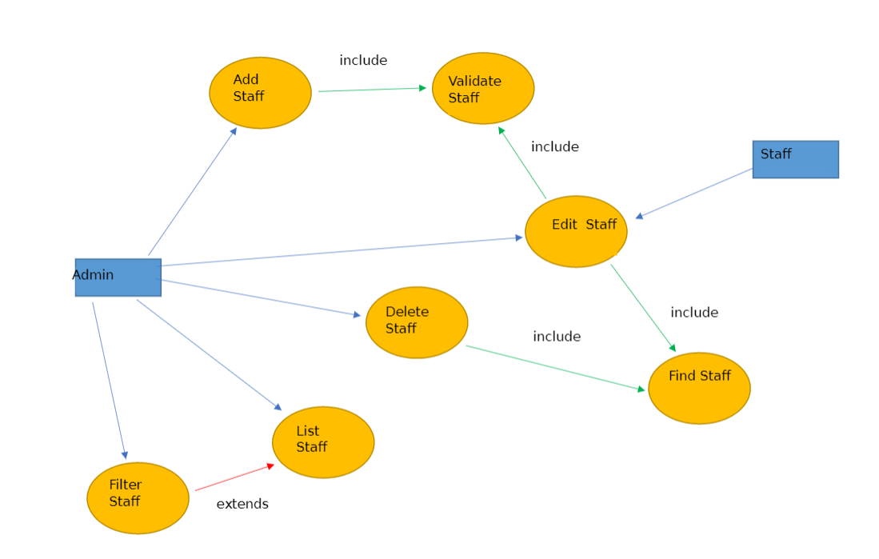

**Template4u LTD**



**Allocated Component:** Product List

**Developer:** Dawid Malecki

**Overview:**

Customers can browse and list the available collection of web templates. System will be able to add one and more templates into web page to let customer view them. On a product list page, customers will be able to see a list of all products including their name, price, created date, product's description and information about product's availability. They will be also able to sort them in ascending and decreasing order by price. Descriptions will be stored in the database as a text data type under the correct column. Every template will be able to be deleted, added and edited or updated by the website admin. Customers will have an opportunity to find a product by name, validate, sort by price and list all of them.

**Individual Table Designs**

**tblProductList**

|  |  |
| --- | --- |
| ProductId | INT, **Primary key** |
| ProductName | VARCHAR(50) |
| ProductDescription | TEXT |
| Price | INT |
| DateAdded | DATETIME |
| isAvailable | BIT |

**Test Expected Results [tstProductList & tstProductListCollection]**

|  |  |  |  |
| --- | --- | --- | --- |
| **Test Type** | **Data Type** | **Expected Result** | **Actual Result** |
| Extreme Min | N/A |  | **Error** |
| Min -1 | BLANK | Error | **Error** |
| Min (Boundary) |  | OK | **OK** |
| Min +1 |  | OK | **OK** |
| Max -1 |  | OK | **OK** |
| Max (Boundary) |  | OK | **OK** |
| Max +1 |  | Error | Error |
| Mid |  | OK | **OK** |
| Extreme Max |  | Error | **Error** |
| Invalid data type | N/A |  | **Error** |
| Other tests | N/A |  | **ALL OK** |

I’ve done all tests following guidelines attached to tutor’s tutorial available on blackboard – **not all tests are OK** but some of them **should occur error due to the guidelines**.

**Use case descriptions - Dawid**

|  |  |
| --- | --- |
| Use Case Name (Short two or three word name) | **List products** |
| Use Case Description (Short description) | The user is able to filter products in the system and display all of them or just part of them regarding which filter has been used. |
| Use Case Author(s) (Who wrote this) | Dawid |
| Actor(s) (Who does this) | Users |
| Locations (Where does this happen) | Part of the front-end functionality |
| Primary pathway (What is the normal “happy path” for this use case?) | Filter products  User enters the product list web page  All products are displayed to the user at web page |
| Alternate pathways (What other paths are there that are not the “happy path”?) | There are no products in the system.  A message that there is no products in the system is displayed for user. |
| Exception pathways (What could possibly go wrong?) | Database connection fails  Error displayed to the user advising of connection problem |

|  |  |
| --- | --- |
| Use Case Name (Short two or three word name) | **Sort Products by Price** |
| Use Case Description (Short description) | The user sort products from the system by price |
| Use Case Author(s) (Who wrote this) | Dawid |
| Actor(s) (Who does this) | Users |
| Locations (Where does this happen) | Part of the front-end functionality |
| Primary pathway (What is the normal “happy path” for this use case?) | Filter Products  User is able to sort products by price ascending or descending  Products are being sorted depends on parameters |
| Alternate pathways (What other paths are there that are not the “happy path”?) | There are no products in the system.  A message that there is no products in the system is displayed for user. |
| Exception pathways (What could possibly go wrong?) | Database connection fails  Error displayed to the user advising of connection problem |

|  |  |
| --- | --- |
| Use Case Name (Short two or three word name) | **Check Product's Availability** |
| Use Case Description (Short description) | The user enter name or id of product which is being searched |
| Use Case Author(s) (Who wrote this) | Dawid |
| Actor(s) (Who does this) | Users |
| Locations (Where does this happen) | Part of the front-end functionality |
| Primary pathway (What is the normal “happy path” for this use case?) | Check Availability  User is able to find every product by its name or id |
| Alternate pathways (What other paths are there that are not the “happy path”?) | The id or name does not exist in the system  The message with information about incorrect id or name is displayed to the user |
| Exception pathways (What could possibly go wrong?) | ID or name does not exist in database |

|  |  |
| --- | --- |
| Use Case Name (Short two or three word name) | **Delete Product** |
| Use Case Description (Short description) | The administrator deletes product from the system |
| Use Case Author(s) (Who wrote this) | Dawid |
| Actor(s) (Who does this) | Administrator |
| Locations (Where does this happen) | Part of the back-end functionality |
| Primary pathway (What is the normal “happy path” for this use case?) | Delete product from the system  Administrator is able to delete product from the system |
| Alternate pathways (What other paths are there that are not the “happy path”?) | Successful deletion  The message with information about deleting product from the system. |
| Exception pathways (What could possibly go wrong?) | Administrator didn't choose which product need to be deleted. |

|  |  |
| --- | --- |
| Use Case Name (Short two or three word name) | **Add Product** |
| Use Case Description (Short description) | The administrator adds product to the system |
| Use Case Author(s) (Who wrote this) | Dawid |
| Actor(s) (Who does this) | Administrator |
| Locations (Where does this happen) | Part of the back-end functionality |
| Primary pathway (What is the normal “happy path” for this use case?) | Add product to product list  Administrator is able to add product to the system |
| Alternate pathways (What other paths are there that are not the “happy path”?) | The name of the product already exists  The message with information about existing product is being displayed |
| Exception pathways (What could possibly go wrong?) | Name of the adding product already exists in a database. |

|  |  |
| --- | --- |
| Use Case Name (Short two or three word name) | **Change product's description** |
| Use Case Description (Short description) | The administrator changes product's description in the system |
| Use Case Author(s) (Who wrote this) | Dawid |
| Actor(s) (Who does this) | Administrator |
| Locations (Where does this happen) | Part of the back-end functionality |
| Primary pathway (What is the normal “happy path” for this use case?) | Change description of the product  User is able to see new description of the product. |
| Alternate pathways (What other paths are there that are not the “happy path”?) | The description is being changed.  Administrator is able to change description of already existing product. |
| Exception pathways (What could possibly go wrong?) | Description of the product is too long. |

|  |  |
| --- | --- |
| Use Case Name (Short two or three word name) | **Validate by product's name** |
| Use Case Description (Short description) | The user is able to find product by its name. |
| Use Case Author(s) (Who wrote this) | Dawid |
| Actor(s) (Who does this) | User |
| Locations (Where does this happen) | Part of the front-end functionality |
| Primary pathway (What is the normal “happy path” for this use case?) | Finding product by name or keywords.  User is able to find product by its name or keyword such as first charts of product etc. |
| Alternate pathways (What other paths are there that are not the “happy path”?) | The product has been found by its name or keywords. |
| Exception pathways (What could possibly go wrong?) | The name of searching product or keywords cant be find in the system  The message with information that product or keywords cant be find in the system |

**Individual Use case diagram**

